CRUD based Blog web application (BlogScript)
Project Report
Version 3.0
SUMMER INTERNSHIP REPORT EVALUATION
BCASI23501
BACHELOR OF COMPUTER APPLICATION


PROJECT GUIDE:  MR. NITIN KUMAR SAINI  & MS. VRATIKA GUPTA | SUBMITTED BY:  PANKAJ KUMAR DAS  RAHUL KUMAR SENUHAR  BANTY MISHRA

COLLEGE OF COMPUTING SCIENCE & INFORMATION TECHNOLOGY
TEERTHANKER MAHAVEER UNIVERSITY, MORADABAD

ACKNOWLEDGEMENT

We would like to express our sincere gratitude to all those who have contributed, directly or indirectly, to the successful completion of the BlogScript – CRUD Based Blog Web Application project.

First and foremost, we are deeply thankful to our project guides Mr. Nitin Kumar Saini and Ms. Vratika Gupta for their constant guidance, encouragement, and valuable suggestions throughout the development of this project. Their technical insights and timely feedback played a crucial role in shaping the project and improving its overall quality.

We would also like to thank the College of Computing Science & Information Technology, Teerthanker Mahaveer University, Moradabad, for providing us with the necessary infrastructure, resources, and a supportive learning environment to carry out this internship project successfully.

Our sincere appreciation goes to the faculty members and lab staff who extended their cooperation and support whenever required during the project work.

We are grateful to our friends and peers for their constructive discussions, testing support, and motivation throughout the project lifecycle.

Finally, we express our heartfelt thanks to our parents and family members for their continuous encouragement, patience, and moral support, which inspired us to complete this project successfully.

This project has been a valuable learning experience that enhanced our technical skills, teamwork, and practical understanding of full-stack web development.

Submitted by:
Pankaj Kumar Das (TCA2301489)
Rahul Kumar Senuhar (TCA2301558)
Banty Mishra (TCA2301154)
Place: Moradabad
Date:
DECLARATION

We hereby declare that this Project Report title CRUD based blog web application (BlogScript) submitted by us and approved by our project guide, Faculty of Engineering and Computing Sciences . Teerthanker Mahaveer University, Moradabad is a Bonafide work undertaken by us and it is not submitted to any other university or institution for the award of any degree diploma / certificate or published any time before .
Project ID:
Title | Name | Signature
Student Name : | Pankaj Kumar Das (TCA2301489)
Student Name : | Rahul Kumar Senuhar(TCA2301558)
Student Name : | Banty Mishra (TCA2301154)
Project Guide : | Mr. Nitin Kumar Saini
Project Guide : | Ms. Vratika Gupta

BRIEF ABOUT THE COMPANY

The internship for the BlogScript – CRUD Based Blog Web Application was carried out under ApexPlanet Software Pvt. Ltd., a growing technology-driven company focused on delivering modern web and software solutions. ApexPlanet is known for providing industry-oriented training, internships, and real-time project exposure to students and fresh graduates, helping them bridge the gap between academic learning and practical development.
The company works in areas such as web development, software solutions, cloud-based applications, digital services, and IT consultancy. ApexPlanet emphasizes hands-on learning, project-based training, and best coding practices, enabling interns to gain confidence in real-world development environments.
During the internship period, ApexPlanet provided structured guidance, technical mentoring, and continuous support that helped in understanding full-stack development concepts, database management, application security, and deployment processes. The professional environment encouraged innovation, problem-solving, and teamwork.

Company mission
Deliver high-quality, scalable, and secure software solutions
Empower students and professionals through practical, skill-based training
Promote innovation and continuous learning in emerging technologies
Bridge the gap between theoretical knowledge and industry requirements
Build a strong community of skilled developers and IT professionals

Company contact details
Company Name: ApexPlanet Software Pvt. Ltd.
Industry: Software Development & IT Training
Website : www.apexplanet.in
Email : info@apexplanet
Table Of Contents
- Project Title _________________________________________________ 4
- Project Domain_______________________________________________ 4
- Problem Statement___________________________________________ 4
- Project Description____________________________________________ 4
4.1 Scope of the Work________________________________________ 5
4.2 Project Modules_________________________________________ 5
4.3 Context Diagram_________________________________________ 6
- Implementation Methodology___________________________________ 6
- Technologies to be Used________________________________________ 7
6.1 Software Platform_________________________________________8
6.2 Hardware Platform________________________________________ 8
6.3 Tools Used_______________________________________________8
- Advantages of This Project______________________________________ 9
- Assumptions, If Any____________________________________________9
- Future Scope and Further Enhancement of the Project________________9
- Project Repository Location____________________________________ 10
- Definition, Acronyms, and Abbreviations_________________________ 11
- Conclusion__________________________________________________ 11
- References__________________________________________________12
- Appendix___________________________________________________ 12
Appendix Details:
A. Data Flow Diagram (DFD)
B. Entity Relationship Diagram (ERD)
C. Use Case Diagram (UCD)
D. Data Dictionary (DD)
E. Screenshots

Project Title
This CRUD-based blog web application is designed to simplify the process of creating, managing, and sharing blog posts online in an efficient and user-friendly manner. The term CRUD stands for Create, Read, Update, and Delete, which are the four fundamental operations required to manage data in any modern web application. These operations form the core functionality of BlogScript and ensure complete control over blog content.
In BlogScript, the Create operation allows users to generate new blog posts by entering essential details such as the post title, content, and related images. The platform provides an intuitive and easy-to-use editor that enables authors to focus on writing without technical complexity. This feature supports structured content creation, making the blogging process smooth even for beginners.

The Read operation enables users and visitors to view published blog posts. All posts are displayed in a clean, organized, and responsive interface that adapts seamlessly to both desktop and mobile devices. Readers can browse through different posts, access detailed content pages, and enjoy a consistent reading experience. The optimized layout ensures fast loading and improved readability across various screen sizes.
The Update functionality gives authors the flexibility to modify their existing blog posts whenever required. Users can edit titles, update content, or replace images to keep information accurate and up to date. This feature is particularly useful for maintaining long-term content relevance and correcting errors after publication.
The Delete operation allows users to permanently remove blog posts that are no longer required. This ensures proper content management and prevents outdated or unnecessary posts from cluttering the platform. Deletion operations are securely handled to avoid accidental data loss.
Overall, the CRUD-based architecture of BlogScript provides a structured, efficient, and scalable approach to content management. By implementing these core operations, the platform ensures full lifecycle control over blog posts while maintaining simplicity, performance, and usability. With its strong CRUD foundation, BlogScript can be easily extended with advanced features such as comments, likes, search functionality, SEO optimization, and user role management in future versions.

Project Domain
Web development using PHP and MySQL provides a powerful and reliable foundation for building dynamic and database-driven web applications. In this project, these technologies are used to develop a user-friendly blog application that allows users to efficiently manage their scripted blog content. PHP serves as the server-side scripting language responsible for application logic, while MySQL is used as the backend database to store and manage user data and blog posts.
The blog application enables users to perform all essential CRUD operations—Create, Read, Update, and Delete—on blog posts. Users can create new blog entries by providing titles, content, and other relevant details through structured forms. Once published, these blog posts can be read by users through a clean and responsive interface designed for easy navigation and readability.

Problem Statement
In today’s digital era, content creators often face difficulties in finding a minimal and distraction-free blogging platform where they can quickly publish their ideas. Many existing platforms are overloaded with advertisements, complex interfaces, and unnecessary features that divert attention away from content creation. As a result, creators struggle to focus on writing and managing their work efficiently.
Another major challenge faced by creators is content ownership and control. They require a system where their content remains secure, private, and fully manageable at any time. Creators want the freedom to edit, update, or delete their posts without restrictions, ensuring that their published content always reflects their latest ideas and perspectives.
BlogScript addresses these challenges by providing a personal and user-friendly blogging space designed specifically for creators who value simplicity and control. The platform allows users to manage their profiles, write blog posts, and modify or remove content whenever required. With an intuitive interface, BlogScript ensures that users can focus entirely on content creation without unnecessary distractions.
Security is a key focus of the platform. BlogScript includes secure authentication and session management, ensuring that only authorized users can access and manage their content. This builds trust among creators and guarantees content safety.

Project Description
``
To ensure security and privacy, BlogScript includes a secure authentication system. User passwords are stored using encryption techniques to prevent unauthorized access. The platform also provides a password reset functionality, allowing users to recover their accounts safely in case they forget their credentials. This feature enhances reliability and user trust in the system. BlogScript is designed with a clean and intuitive user interface, making navigation simple and smooth. The layout is organized in a way that allows users to focus on content creation without distractions. Forms, buttons, and pages are structured clearly, ensuring a pleasant user experience across different devices.
From a technical perspective, the application is backed by a well-structured database that efficiently stores user data, blog posts, and related information. Proper relationships between tables ensure data consistency and integrity. This structured approach makes the system scalable and easier to maintain or upgrade in the future.
Overall, BlogScript emphasizes simplicity, security, and usability. It serves as an ideal platform for beginners, students, and content creators who want a straightforward blogging solution. With its strong foundation and scope for future enhancements, BlogScript has the potential to grow into a more advanced blogging platform with additional features such as comments, likes, SEO optimization, and mobile app integration.

Scope of the Work
The scope of this project involves building a full-stack web application using PHP and MySQL as backend technologies and HTML, CSS, and JavaScript for frontend development. The system includes:
- User registration and login system with password hashing
- Post creation, editing, and deletion
- Secure password reset via email verification

Project Modules

- User Authentication Module
- Sign Up: Allows new users to create an account with username, email, and password.
- Login: Provides secure access to the platform using email and password.
- Email Verification: Confirms the user’s email before account activation.
- Password Reset / Update: Enables users to reset or update their password securely via email.
- Blog Post Management Module
- Create Post: Users can write and publish blogs.
- Read Post: Blogs are displayed on the homepage or dashboard.
- Update Post: Users can edit/update their previously created posts.
- Delete Post: Users can remove their posts from the platform.
- Email Integration Module
- Sends verification emails during sign-up.
- Delivers password reset link to registered users.
- Sends notification emails (optional future scope).
- Database Management Module
- Database schema includes users and posts tables.
- Handles CRUD operations for both users and posts.
- Ensures relational integrity between users and their posts.
- Security Module
- Passwords are hashed using PHP’s password_hash() and password_verify()
- SQL Injection prevention using prepared statements.
- Secure session management and validation.

  - Context Diagram
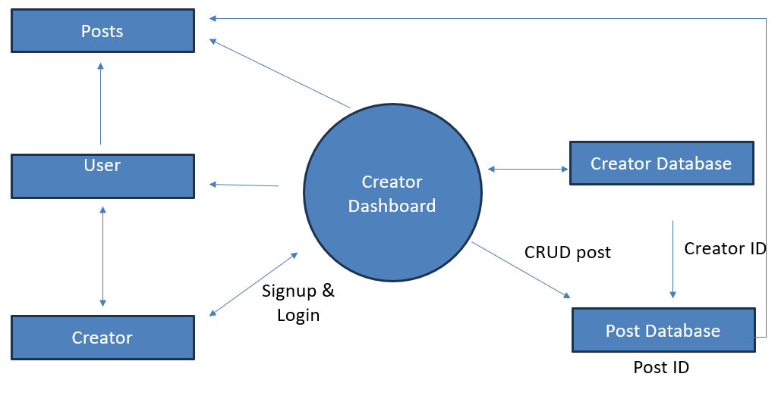

Implementation Methodology

Step 1: Requirement Analysis
- Identified core features: user authentication, blog post management, and email verification.
- Finalized technology stack: PHP, MySQL, HTML, CSS, JavaScript, PHPMailer.
Step 2: System Design
- Designed the database schema with users and posts tables.
- Designed responsive frontend layouts for signup, login, dashboard, and post pages.
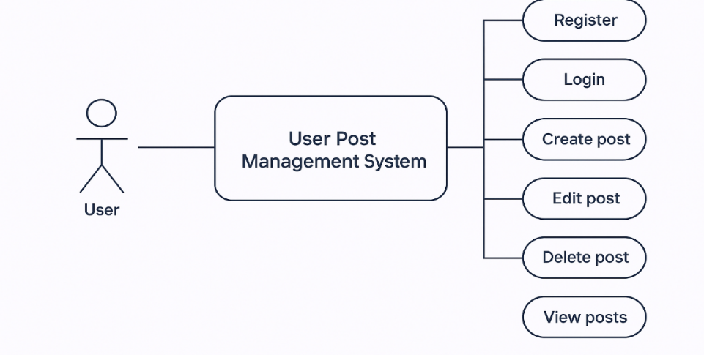

Step 3: Backend Development
- Implemented User Authentication (signup, login, password hashing).
- Added Email Verification using PHPMailer.
- Developed CRUD operations for posts (create, read, update, delete).
- Implemented password reset functionality with email link.

Step 4: Frontend Development
- Built responsive UI using HTML, CSS (custom + media queries), and JavaScript.
- Integrated forms for login, signup, post creation, and update.
Step 5: Integration
- Integrated database queries with prepared statements for security.
- Linked PHPMailer for sending verification and reset emails.
Step 6: Testing
- Conducted unit testing for individual modules.
- Performed integration testing for login, signup, and post management.
- Tested the platform on different devices for responsive design.
Step 7: Deployment & Future Scope
- Deployed the project on local XAMPP server for testing.
- hosted on a live server with domain and SSL for real-world use.
- Future scope includes adding admin dashboard, comments, and SEO optimization.

Technologies to be used

6.1 Software Platform
- Frontend Technologies
- HTML5 - For creating the structure and layout of web pages.
- CSS3 - For styling, responsiveness, and UI design.
- JavaScript (jQuery) - For client-side validation, interactivity, and DOM manipulation.
- Backend Technologies
- PHP (Core PHP) - For server-side scripting, handling requests, implementing business logic, and integrating with the database.
- PHPMailer - For sending verification and password reset emails using SMTP.
- Database
- MySQL - To store and manage user accounts, authentication data, and blog posts.
- Users table (for user details, passwords, verification codes)
- posts table (for blog posts created by users)
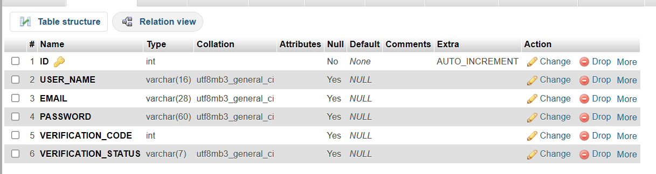

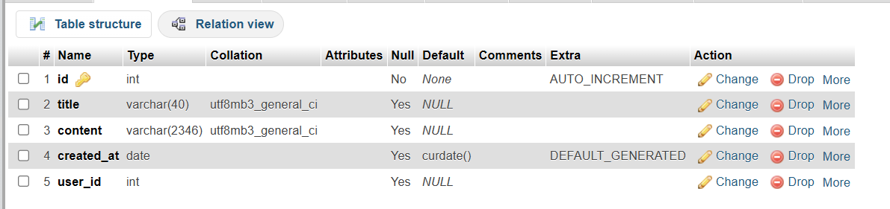
- Server Environment
- XAMPP (Apache, MySQL, PHP, Perl) - Used as the local development environment.
- Apache Server - To host and run the PHP application locally.
- Development Tools
- VS Code - Code editor for writing and debugging code.
- phpMyAdmin - For managing MySQL databases.
- Git/GitHub (optional) - For version control and project collaboration.
- Other Supporting Tools
- Google Fonts (Poppins) - For better typography.
- Browser Developer Tools - For testing responsiveness and debugging frontend issues.
- Hosting Server
- Infinity free - For free hosting and testing server with SSL certificate and sub domain.
6.2 Hardware Platform
RAM, Hard Disk , OS, Editor etc

Advantages of this Project

Simple and User-Friendly Interface

The platform is designed with simplicity in mind, allowing users to navigate easily without any technical difficulty. The clean layout ensures that users can focus on writing and managing their blogs rather than learning complex features. This makes the application suitable for beginners as well as experienced users.
- Secure Authentication System
BlogScript provides a secure login and signup system using password hashing techniques, which protects user credentials from unauthorized access. The password reset feature further enhances security by allowing users to safely recover their accounts without compromising data integrity.
- Email Verification for Account Authenticity
The inclusion of email verification ensures that only genuine users can create accounts. This helps prevent fake registrations, reduces spam, and increases the overall trustworthiness of the platform.
- Responsive Design
BlogScript is built with a responsive design that adapts smoothly to both desktop and mobile devices. This ensures a consistent user experience across different screen sizes and allows users to access and manage their blogs anytime and anywhere.
- Practical for Real-World Blogging Needs
The project addresses real-world blogging requirements such as security, content control, and ease of use. Its practical features make it suitable for personal blogging, educational use, or small-scale content platforms.
- Customizable and Scalable
The system is designed to be easily customizable. Additional features such as comments, likes, categories, and SEO tools can be integrated in the future. This makes the project scalable and adaptable to different user
- Complete Blog Management with CRUD Operations
The application supports all essential CRUD operations (Create, Read, Update, Delete), allowing users full control over their blog content. Authors can publish new posts, update existing ones, and remove content whenever required, ensuring flexibility and efficient content management.

Assumptions, if any
The project assumes that users have basic internet access and fundamental knowledge of using web applications. It is also assumed that users will provide valid email addresses for account verification and password recovery. The system is designed for small to medium-scale usage, where server resources and network connectivity remain stable.

Future Scope and further enhancement of the Project
The current version of the project provides a strong foundation for a modern blogging platform. However, with the rapid growth of digital content creation and user expectations, there are several opportunities to enhance the system further. These future enhancements can significantly improve user engagement, scalability, performance, and overall usability. The following points describe the possible future scope and improvements that can be implemented in the project.

- Comments and Likes System
One of the most important future enhancements is the implementation of a Comments and Likes System. This feature will allow readers to actively interact with blog posts by sharing their opinions, feedback, and suggestions.
A comments system encourages healthy discussions between readers and authors, making the platform more interactive and community-driven. Users will be able to post comments, reply to other comments, and engage in meaningful conversations. Moderation features can also be added to prevent spam and abusive content.
The likes system will enable readers to express appreciation for posts they enjoy. This feature not only boosts author motivation but also helps identify popular content. Additionally, likes data can be used to rank posts, display trending blogs, and improve content recommendations.
- Rich Text Editor
Currently, content creation may be limited to plain text. A Rich Text Editor can greatly enhance the content writing experience for authors. This editor will allow users to format text using bold, italics, headings, lists, and block quotes.
Authors will also be able to add images, embed videos, insert links, and include multimedia elements directly into their blog posts. This makes the content visually appealing and more engaging for readers. Popular editors like TinyMCE, CKEditor, or Quill can be integrated for this purpose.
A rich text editor improves content quality, professionalism, and readability, making the platform suitable for serious bloggers and content creators.

- SEO Optimization
Search Engine Optimization (SEO) is a crucial factor for any blogging platform. Future enhancements can include SEO-friendly features to improve the visibility of blog posts on search engines like Google.
This may include:
- Custom meta titles and descriptions
- SEO-friendly URLs
- Keyword optimization
- Sitemap generation
- Faster page loading speeds
By implementing SEO optimization, blog posts can rank higher in search results, leading to increased traffic and better reach. This enhancement will benefit both content creators and platform administrators by increasing platform popularity.
- User Profile Customization
Another major enhancement is User Profile Customization. Currently, users may have basic profiles, but future versions can allow more personalization options.
Users will be able to upload profile pictures, add a short bio, include social media links, and showcase their published posts. This creates a personal identity for authors and builds trust among readers.
Profile customization also enhances professionalism and allows readers to follow their favorite authors. In the future, features like author badges, follower counts, and achievements can also be added.
- Notification System
A Notification System can significantly improve user engagement and retention. Notifications can be sent through email or displayed within the application.
Examples of notifications include:
- New blog posts from followed authors
- Likes and comments on user posts
- Replies to comments
- Important platform updates
This feature keeps users informed and encourages them to revisit the platform regularly. Real-time notifications can be implemented using modern technologies, while email notifications can be used for important alerts.
- Mobile App Integration
With the increasing use of smartphones, Mobile App Integration is a valuable future enhancement. The project can be extended into a full-fledged Android and iOS application.
A mobile app will provide:
- Faster access to content
- Push notifications
- Offline reading support
- Better user experience on mobile devices
The mobile app can be developed using technologies such as React Native or Flutter and connected to the existing backend through APIs. This will allow users to access the platform anytime and anywhere, significantly increasing user engagement

Project Repository Location
Repository: https://github.com/Pankajdas0025/ApexPlanet_Internship_Project
Live : https://blogscriptapp.free.nf/

S# | Project Artifacts | Location | Verified by Project Guide | Verified By Lab In-Charge
1. | Project Synopsis Report | Pankajdas0025/ApexPlanet_Internship_Project/Report/Synopsis
2. | Project Progress updates | Pankajdas0025/ApexPlanet_Internship_Project/Report/Update
3. | Project Requirement Specification | Pankajdas0025/ApexPlanet_Internship_Project/Report
4. | Project Report | Pankajdas0025/ApexPlanet_Internship_Project/Report
5. | Test Repository | Pankajdas0025/BlogScript-website
6. | Project Source Code | https://github.com/Pankajdas0025/ApexPlanet_Internship_Project

Definition , Acronyms, and Abbreviations

- CRUD: Create, Read, Update, Delete – basic operations performed on database records.
- PHP: Hypertext Preprocessor – a server-side scripting language used for web development.
- MySQL: An open-source relational database management system.
- SMTP: Simple Mail Transfer Protocol – used for sending emails.
- UI: User Interface – the visual part of the application.
- UX: User Experience – overall experience of users while interacting with the system.
- ERD: Entity Relationship Diagram – represents database structure.
- DFD: Data Flow Diagram – shows flow of data within the system.

Conclusion
The BlogScript project successfully demonstrates the design and implementation of a CRUD-based blog web application that addresses the essential needs of modern content creators. By providing a clean and intuitive interface, the system allows users to register securely, authenticate their accounts, and manage blog posts efficiently through create, read, update, and delete operations. The inclusion of email verification and password reset functionality strengthens account security and enhances user trust in the platform.
From a technical perspective, the project effectively integrates frontend technologies such as HTML, CSS, and JavaScript with backend technologies like Core PHP and MySQL, ensuring smooth interaction between the user interface and the database. The use of prepared statements and password hashing techniques helps protect sensitive user data and prevents common security vulnerabilities. Additionally, the modular architecture of BlogScript improves code maintainability and allows future developers to extend features with minimal effort.
Overall, BlogScript serves as a practical real-world application that reflects strong understanding of full-stack web development concepts. It not only fulfils the academic objectives of the internship but also provides a scalable foundation for future enhancements such as comments, admin controls, SEO optimization, and mobile integration. The project enhances problem-solving skills, reinforces database design knowledge, and prepares the developer for professional web development challenges.

References

PHP Documentation Team
https://www.php.net/docs.php

Oracle Corporation. MySQL Documentation
https://dev.mysql.com/doc/

Geeksforgeeks. Web Development Tutorials (HTML, CSS, JavaScript, PHP). Available at:
https://www.geeksforgeeks.org

W3C. HTML5 Specification
https://www.w3.org/TR/html5/

Mozilla Developer Network (MDN). Web Docs for HTML, CSS, and JavaScript
https://developer.mozilla.org

GitHub. GitHub Documentation
https://docs.github.com

14. Appendices

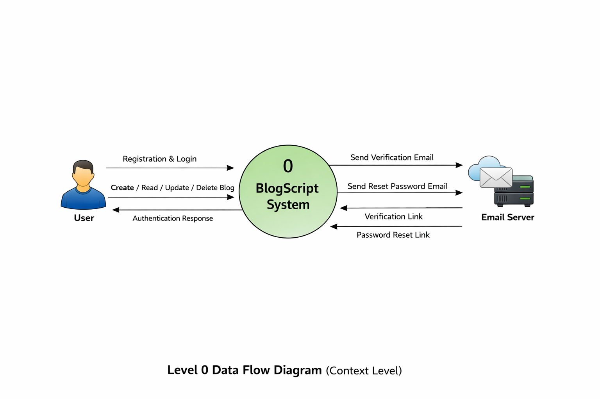
A. Data Flow Diagram (DFD)
Shows how data moves between users, the application, and the database during login, blog creation, and management processes.

B. Entity Relationship Diagram (ERD)
Illustrates the relationship between users and posts tables, where one user can create multiple blog posts.

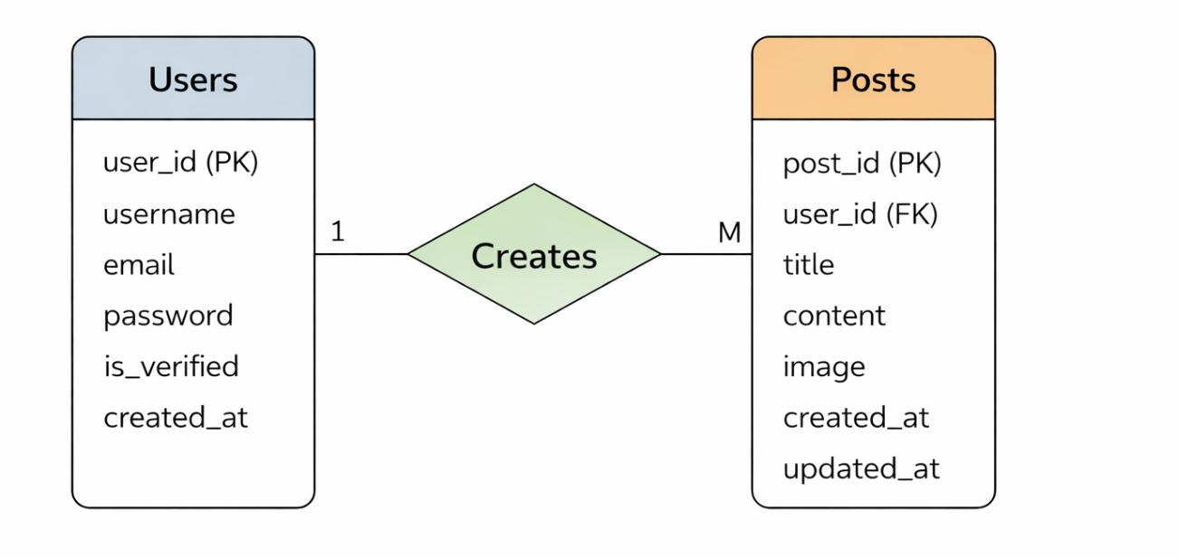

C. Use Case Diagram (UCD)
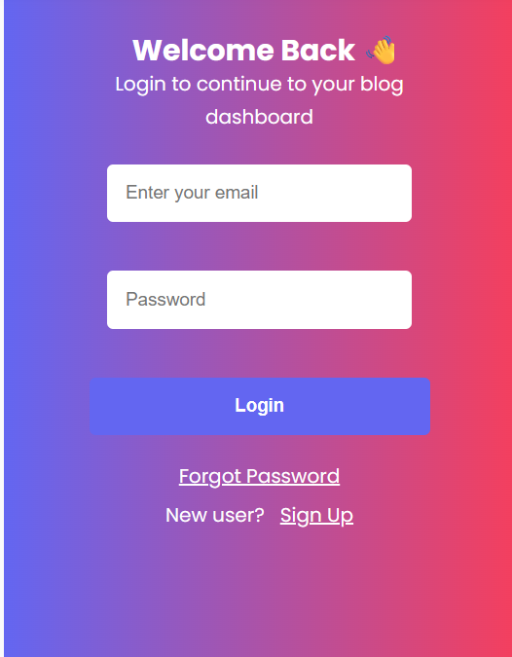
Depicts user interactions such as registration, login, create blog, edit blog, delete blog, and logout.
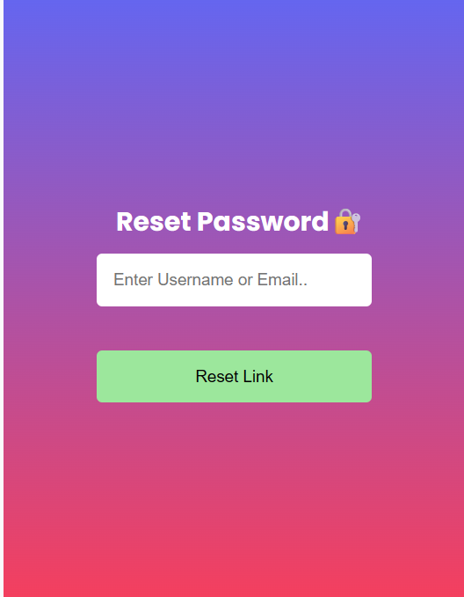
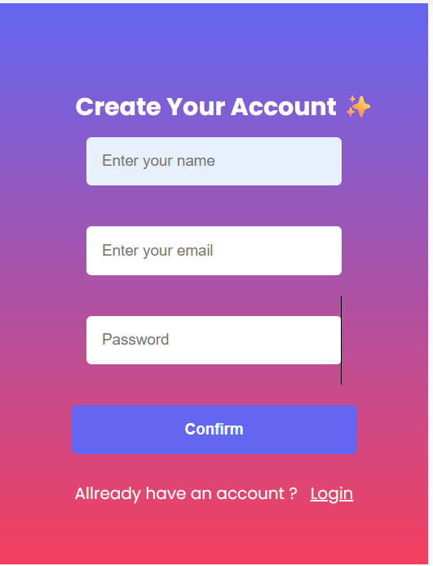
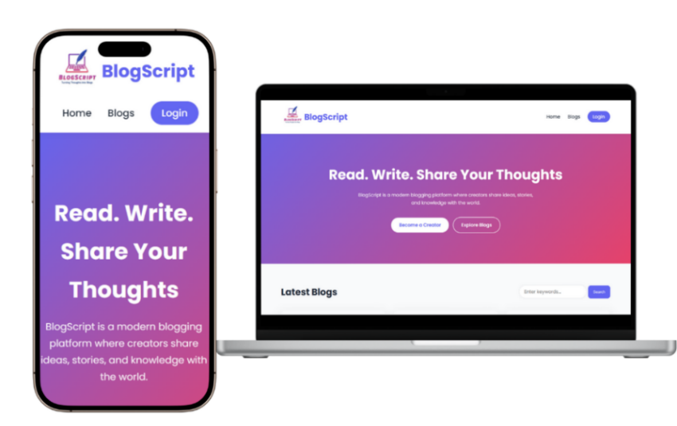
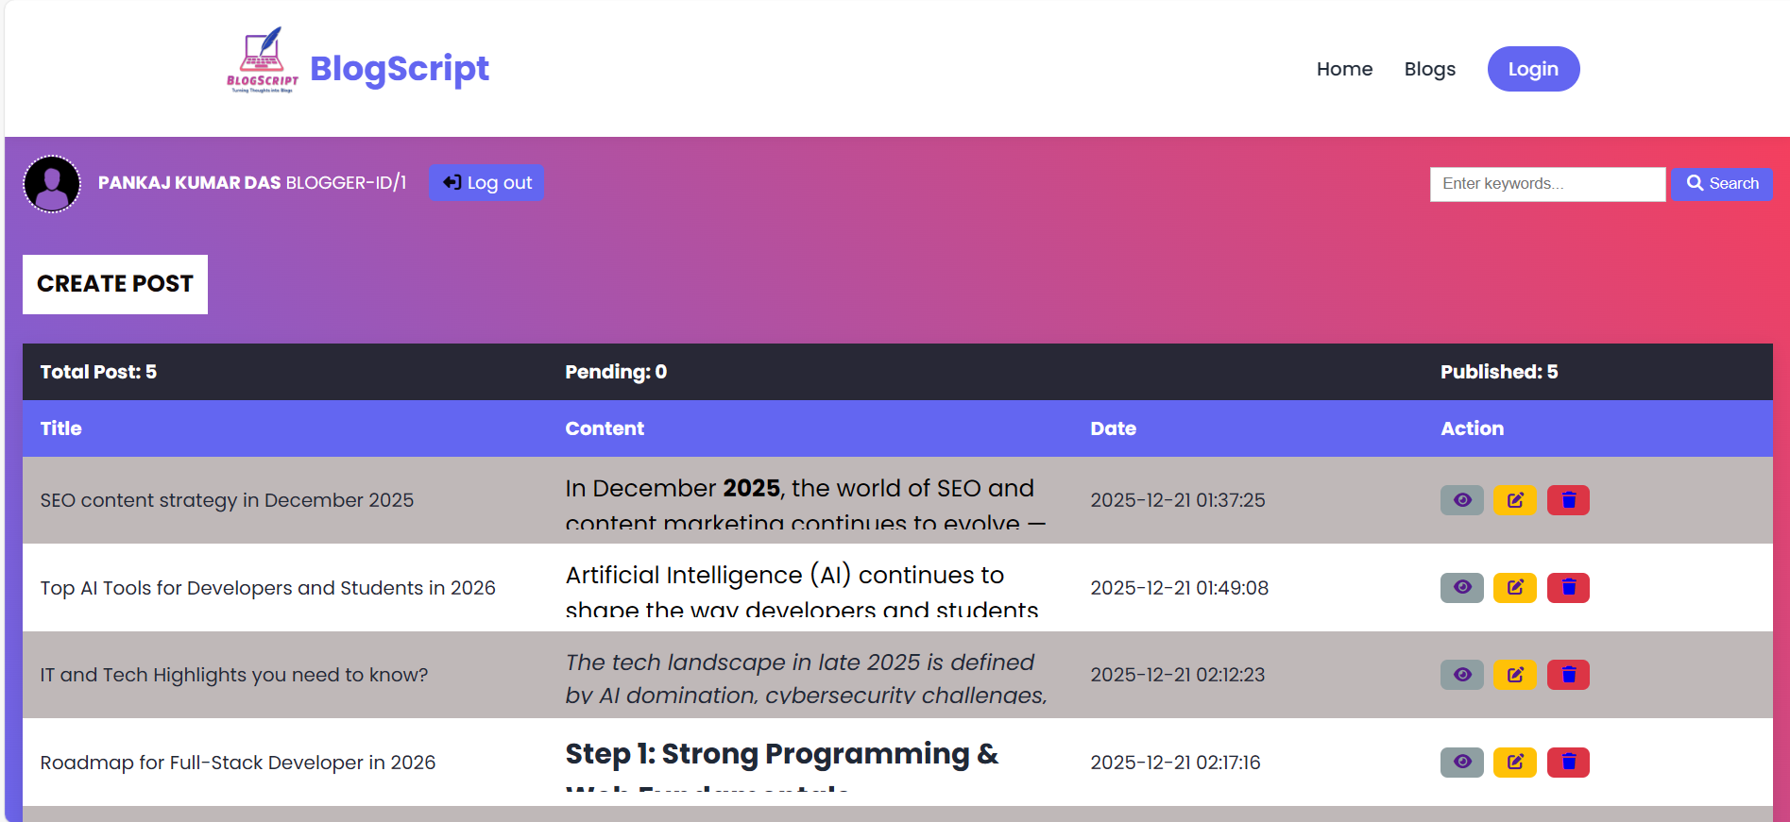

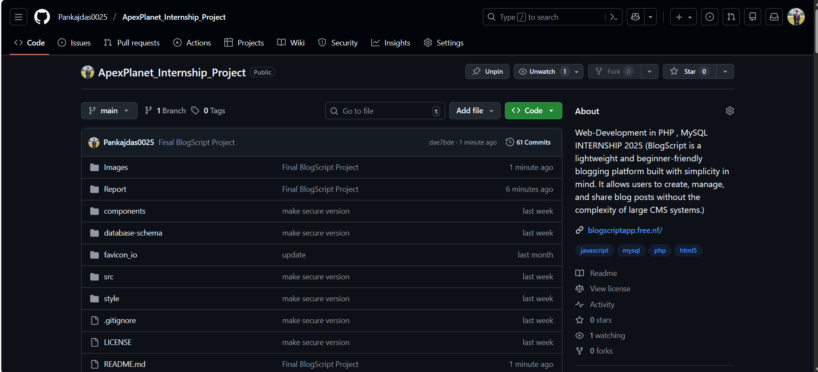

D. Data Dictionary (DD)

Users table

Field Name | Data Type | Description
ID | INT | Primary Key
USER_NAME | VARCHAR(16) | User name
EMAIL | VARCHAR(28) | User email
PASSWORD | VARCHAR(60) | Hashed password
VERIFICATION_CODE | INT(8) | Email verification status
VERIFICATION_STATUS | VARCHAR(7) | Pending and active

Posts table
Field Name | Data Type | Description
id | INT | Primary Key
title | VARCHAR(255) | Blog title
content | TEXT | Blog content
image | VARCHAR(255) | Image path
created_at | Date | Post creation date
User_id | int | Author of the post

Attachments
